1

Assignment No: 01


Department of Computer Science
Iqra University Islamabad

Probability and Statistics

Maqsood Ahmed

ID: 38186
2

Q: [CLO1]

You are a data analyst at a logistics company that is reviewing customer service response times to improve customer satisfaction. The company has recorded the time (in minutes) it takes for customer service representatives to respond to 50 randomly selected customer inquiries. Due to high variability in response times, the company wants to analyze the median response time rather than the mean, to better understand the typical customer experience without being skewed by outliers.

The response times (in minutes) for the sample of 50 inquiries are as follows:

[15, 17, 23, 42, 15, 25, 30, 45, 55, 60, 15, 25, 18, 20, 22, 50, 30, 17, 21, 40, 15, 25, 60, 20, 50, 18, 19, 21, 22, 23, 24, 45, 16, 22, 18, 19, 23, 60, 55, 50, 24, 18, 30, 45, 55, 60, 22, 21, 25, 19]

Calculate the median response time for this dataset to determine the central response time most customers experience.

Explain why the median is a better measure than the mean in this context, given that there are unusually high response times.

Interpret the median value in terms of what it reveals about customer experience. Based on the median, would the company need to focus on decreasing response times? Why or why not?

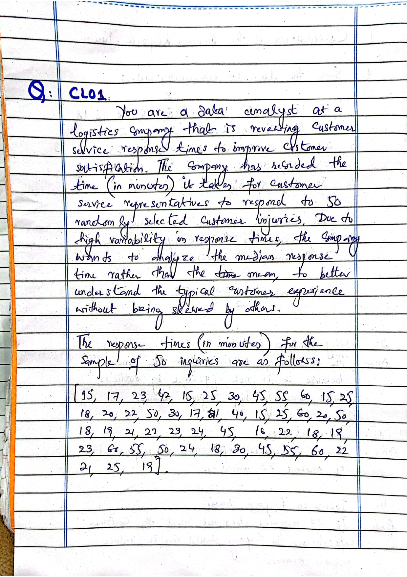

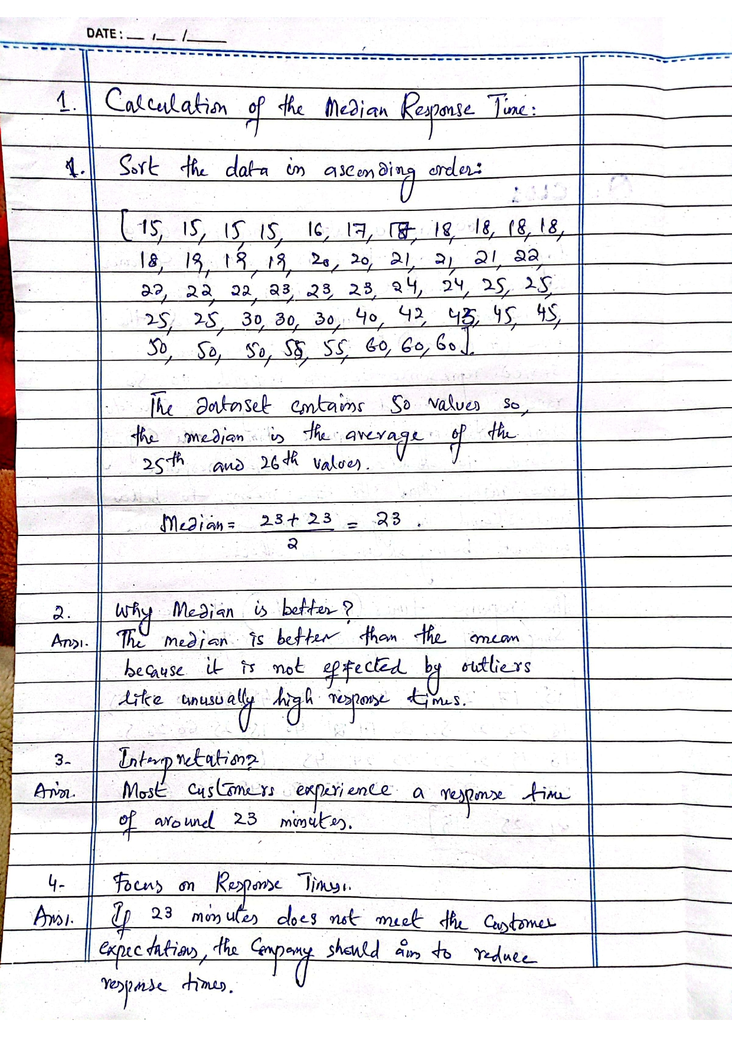
The End

